Project Design Phase
Problem – Solution Fit Template

Date | 05 MAY 2026
Team ID
Project Name | Smart Agricultural Production Optimization Engine (OptiCrop)
Maximum Marks | 4 Marks

Problem–Solution Fit Canvas

1. Customer Segment (Who has the problem?)
- Farmers (Small, Medium, and Large Scale)
- Agricultural Researchers
- Government Agriculture Departments
- Agricultural Extension Officers
- Policymakers
- Agricultural Universities and Students

2. Problem (What problem are they facing?)
- Farmers struggle to identify the most suitable crop for their soil and climate.
- Crop selection is mostly based on traditional knowledge rather than scientific analysis.
- Improper fertilizer usage leads to reduced soil fertility.
- Climate changes make farming decisions difficult.
- Crop failures result in financial losses.
- Researchers require efficient tools for analyzing crop-environment relationships.

3. Current Solutions
- Traditional farming experience
- Advice from local farmers
- Agricultural officers
- Soil testing reports
- Internet searches and YouTube videos
- Manual agricultural analysis

4. Customer Pain Points
- Wrong crop selection
- Low agricultural productivity
- High fertilizer and water consumption
- Crop failure due to unsuitable conditions
- Lack of expert guidance
- Time-consuming manual analysis
- Increased cultivation costs

5. Proposed Solution
OptiCrop is an AI-powered Smart Agricultural Production Optimization Engine that analyzes:
- Nitrogen (N)
- Phosphorous (P)
- Potassium (K)
- Temperature
- Humidity
- Soil pH
- Rainfall
Using Machine Learning, the system predicts the most suitable crop and evaluates crop suitability for better agricultural productivity.

6. Key Features
- Smart Crop Recommendation
- Crop Suitability Assessment
- Environmental Analysis
- AI-Based Prediction
- Farmer-Friendly Web Interface
- Research Support Dashboard

7. Value Proposition
- Scientific crop recommendation
- Higher crop yield
- Efficient fertilizer usage
- Better water management
- Reduced farming risk
- Sustainable agriculture
- Data-driven decision making

8. Customer Benefits
- Increased productivity
- Better profits
- Reduced cultivation costs
- Faster farming decisions
- Easy-to-use system
- Improved resource utilization
- Support for sustainable farming

9. Expected Outcomes
- Higher agricultural production
- Improved crop selection
- Better soil management
- Reduced resource wastage
- Enhanced farmer confidence
- Support for agricultural research and policy planning

10. Problem–Behavior–Solution Mapping
Problem | Current Behavior | OptiCrop Solution
Farmers cannot decide which crop to grow. | Depend on experience and local advice. | AI recommends the most suitable crop based on soil and climate conditions.
Low crop yield. | Trial-and-error farming. | Predicts crops with higher productivity.
Excess fertilizer usage. | Apply fertilizers without proper planning. | Uses NPK values for scientific recommendations.
Climate uncertainty. | Depend on weather assumptions. | Considers rainfall, humidity, and temperature during prediction.
Lack of expert support. | Visit agricultural offices. | Instant recommendations through the web application.
Manual agricultural research. | Analyze data manually. | Provides automated machine learning insights.

11. Validation
- Machine Learning model trained using the Crop Recommendation Dataset.
- Predicts suitable crops based on environmental conditions.
- Tested with multiple agricultural datasets.
- Provides fast and accurate recommendations through a Flask web application.

12. Success Criteria
- Accurate crop recommendations.
- Improved crop productivity.
- Reduced fertilizer and water wastage.
- Better decision-making for farmers.
- Increased adoption of AI in agriculture.
- Support sustainable farming practices.
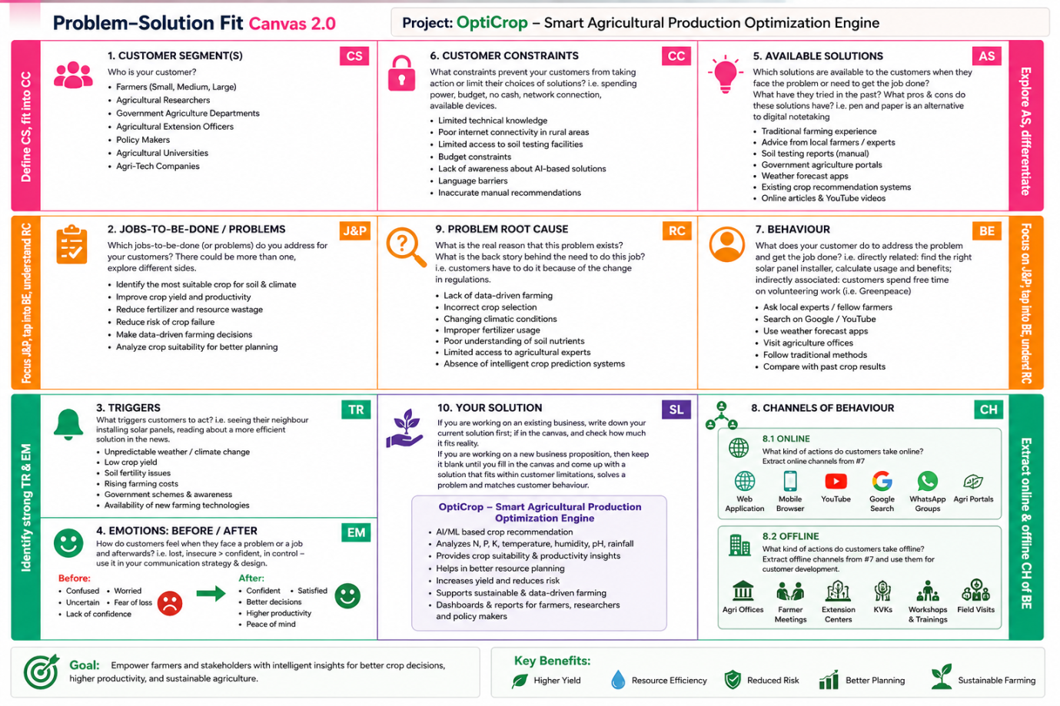

References
- https://www.ideahackers.network/problem-solution-fit-canvas/
- https://medium.com/@epicantus/problem-solution-fit-canvas-aa3dd59cb4fe
This version is formatted in a report style and is suitable for direct inclusion in your Project Design Phase document for 4 marks.

